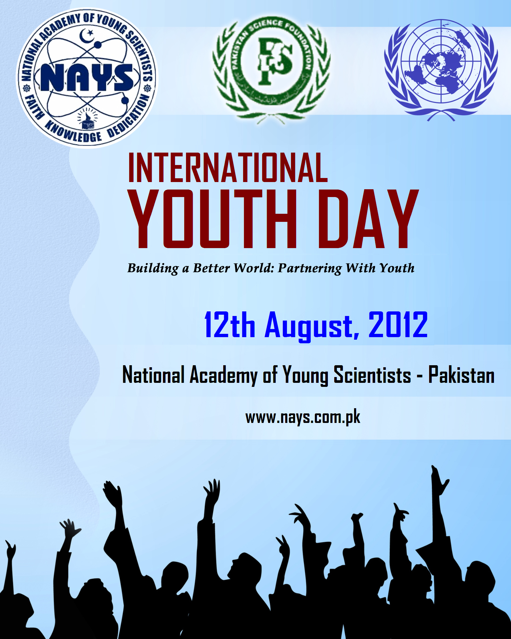

International Youth day will be observed across the world including Pakistan on August 12. National Academy of Young Scientist (NAYS) Pakistan is trying to take initiative for the betterment of Young people in Pakistan. For the very first time, NAYS is going to celebrate “International Youth day” (IYD) in collaboration with United Nations (UN) and Pakistan Science Foundation (PSF). The proposed theme for this year is ***“Building a better world: Partnering with Youth”*** and United Nations is going to include the commemoration of IYD 2012 in Pakistan by our organization.

***“Guard your light and protect it. Move it forward into the world and be fully confident that if we connect light to light to light, and join the lights together of the one billion young people in our world today, we will be enough to set our whole planet aglow.” (Hafsat Abiola)***

Youth may change the future of any nation by changing the world around them. We strongly believe the theme chosen for IYD (2012) is a great effort to develop and engage partnership among the stakeholders around the world and young women and men. The main focus of the day is to raise public awareness about the youth’s issues and set up the process and participation of the young people in the decision making practices.

***"Young people should be at the forefront of global change and innovation. Empowered, they can be key agents for development and peace. If, however, they are left on society's margins, all of us will be impoverished. Let us ensure that all young people have every opportunity to participate fully in the lives of their societies." (Kofi Annan)***

IYD is the event which chiefly celebrates the passion, energy and enthusiasm of young people towards different global issues. They understand their key importance to promote awareness and identify the strong solutions of the problems facing by humanity. They will become the role model for the next generation and reflects upon how practical activities may be developed within their own sphere of work. This day may serve as the gateway to attain the confidence, authority and ability to make decisions in order to raise their own standard of living.

***"No one is born a good citizen; no nation is born a democracy. Rather, both are processes that continue to evolve over a lifetime. Young people must be included from birth. A society that cuts off from its youth severs its lifeline." (Kofi Annan)***

Youth of Pakistan has been suffering from many problems like poverty, education, health, starvation, unemployment, lack of guidance and motivation etc. These are the tragedies that results millions of people despondent with their lives. These directionless young people strongly get involved in to the negative activities which further harm their mental health and thinking capabilities. The best possible solution for youth to trained them various skills in order to restrain unemployment and further bad activities.

***"We have a powerful potential in our youth, and we must have the courage to change old ideas and practices so that we may direct their power toward good ends." (Mary McLeod Bethune)***

We have to prepare our youth to engage the world by educating them for global competence. So that individuals are aware, curious and interested in learning about the world. They can use big ideas from any of the discipline, deploy their expertise to investigate various issues, and recognizes multiple perspectives to take action and to improve the conditions.

***“Youth should be given a chance to take an active part in the decision-making of local, national and global levels.”(Ban-ki-Moon)***

With this in mind, National Academy of Young Scientists (NAYS) and Pakistan science Foundation have joined their hands with United Nations to open the doors for young people, that they should step forward and make their future a better one.

National Academy of Young Scientists (NAYS) has taken some comments (relevant to the theme) from Professors, lecturers, youth leaders and young researchers. These valuable comments are given below:

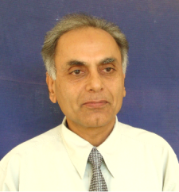

**Prof. Dr. Manzoor Hussain Soomro**

**Chairman**

Pakistan Science Foundation, Islamabad

On the occasion of International Youth Day 2012, I congratulate youth around the globe. My special felicitations to youth of Pakistan, who are playing a vital role for the future of this nation. Young people, boys and girls are the future leaders of their countries and the world and any development without involving youth may not sustain. Thus partnering with youth is the way forward. Pakistan Science Foundation works in partnership with National Academy of Young Scientists (NAYS) Pakistan, for the last couple of years. Not only that but we are also working with youth and even younger students at school level for promotion of Inquiry Based Science Education (IBSE) in Pakistan, thereby linking them with the industrial sector as well. It is my conviction and belief that young people have to be involved in every facet of national development to secure the future peace, harmony and progress of the world. It is very positive that UN has also been encouraging and supporting Youth Forums at highest levels such as UNESCO and I hope that the National Governments around the world would also help organize youth and their partnership in various world issues for a better tomorrow.

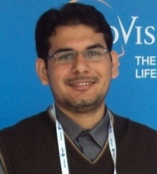

**Aftab Ahmad**

**President NAYS Pakistan**

National Academy of Young Scientists (NAYS) Pakistan

Along with other international days, international youth day is also celebrated each year which signify the important of youth and its role. Partnering with youth will definitely result in a better world. Many international organizations including United Nations (UN) realized that we should engage youth in policy making and other important tasks as youth is future of any nation. Many youth organizations i.e. Global Young Academy, World Academy of Young Scientists, Islamic World Young Scientists Academy and many national young academies came into existence in the last decade to better network the young people and to engage them in policy making. This is very timely and important initiative and will have good impact in future where young people will be more aware of present and future challenges and will have more rational approach to solve these issues.

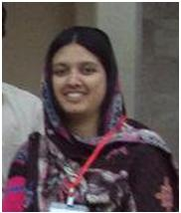

**Aneela Yasmeen**

**Research Officer cum Lecturer**

CEMB, University of Punjab,

Lahore

Every Society is comprised of three main parts, The Old; The Children; and, the most dynamic part of any society i.e. the youth. If we look into any successful story whether it’s about any successful project, or about the success of a nation we find that the Youth has played the major part in that revolution. Today our Youth is more active, energetic, vibrant and ready to work. The only thing which they are facing as hurdle is the lack of opportunities. Whenever they are being provided resources they have done marvelous Job. The coming trends in the world are going to change, so, if we want to see a more successful world joining hands with the most astonishing part of the world would be the best Idea.

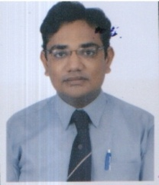

**Sikandar Khan Sherwani**

**Faculty, Department of Microbiology**,

Federal Urdu University of Arts, Science and Technology

Karachi, Pakistan

Being scientist, academician and having visited technologically advanced countries, I strongly realize that our Pakistani youth is brimful of innovative thoughts and crammed with brilliant scientific ideas that would be really grateful and surely pivotal in promoting cutting edge Science and Technology in our country. At the crux of this time, there is a dire need of supporting, encouraging and motivating our young scientific minds. In recent decades, our young Science scholars have proved themselves worthy by producing marvelous scientific recognitions and received appreciation and awards over their ceaseless and relentless efforts thus contribute greatly in revolutionizing science at high momentum. Indeed; remarkable, Science and Technology achievements is a part and parcel to make any nation successful. On this gracious occasion of International Youth Day on 12th August-2012, I would pay congratulate from the core of my heart to National Academy of Young Scientists NAYS)-UN-International and Pakistan Science Foundation (PSF) for organizing this event. I equally wish and sincerely pray meritorious achievements with flying colors to uplift our dear homeland up to the zenith.

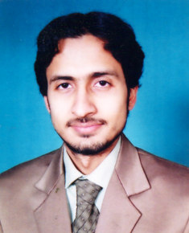

**Muhammad Umer Shafique**

**Lecturer, Applied & Environmental Chemistry**

Center for Undergraduate Studies, University of the Punjab

Youths are back bone to the nation. They can change the future of the society with their thriving and courageous behavior. The youth of Pakistan, despite a huge number of problems like unemployment, poverty, remorselessness, social taboos, drugs, guns and politics, have always been in the front position of movements and political changes, for instance from Pakistan Movement to Independence of Pakistan and Indo-Pak wars, to Fall of Dhaka and Pakistan emerging as "something" on the map of the world to Pakistan becoming the first Islamic nuclear power. They have never let the nation down at any point of time. It is unfortunate that the youth, despite their contributions to national developments, find themselves trapped in a culture marked by guns, violence and drugs. All this has resulted in an unstable economy, a shattered confidence of foreign investors, lawlessness, and a break-up of the social fabric. Our youth has lost its identity and importance. We need to enable our youth to rediscover their identity which they were made to lose over the last 50 years. There must be remedial measures at government, social and individual levels to restore the confidence of the youth in their potential qualities.



**Zeeshan Ahmed**

**Research Scientist**

University of Wurzburg, Germany

It’s true that youth can play a vital role in building a better World but only if they are working hard in their studies and career. Unfortunately today’s most of the youth is not spending their precious time and energies in doing valuable things which not only boost their skills but will also benefit their country and ultimately the World as well.

Today’s hot issues of the most of the young people are e.g. staying at Facebook and being involved in fruitless discussions etc. and keep complaining about bad circumstances, instead living their lives doing something valuable rather than demanding things.

The immediate plan of the young people should be to work hard and first develop their selves by getting good education and becoming a good professional because, “those who can’t help themselves, how can they push country or World to grow”.

It’s true that everyone gets hard situations in life but one should not give up his/her goals, try hard; everything is possible, “believe in your skills than luck”.



**Dr. Reaz Uddin**

**Assistant Professor**

International Center for Chemical and Biological Sciences

In my opinion it’s the best way to engage our youth in positive activities like building a better future. The idea is itself an innovative approach to attract our young people. Considering the on-going bad situation in Pakistan, I believe this event is a fresh air for our educated community.

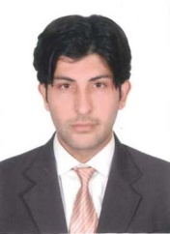

**Aftab Nadeem**

**Research Associate**

BMC, Lund University

*‘‘Building a Better World: Partnering with Youth”* is a nice initiative on behalf of NAYS. Awareness about current advancements in science by organizing lectures from foreign or domestic researchers from different fields of science at school and college level will make it easy for our youth to decide about their future studies in right direction.



**Waqas Saleem**

**Graduate Scientist & Research Assistant**

Sophie Davis School of Biomedical Education, The City College of City University of New York, USA

Great combined effort by NAYS and UN to bridge the gap between youth and their participation. Pakistani youth is the biggest asset of Pakistan which comprises of 68% of population (in 2011). Trend of public discussions with the youth are constantly getting popular, and these efforts must be appreciated as constructive discussions and efforts have solutions embedded in them. Undoubtedly, our youth has got immense potential and they only need proper guidance and channels to contribute their part. I regularly follow NAYS events and workshops to pedagogue across the country, and I sincerely admire team’s enthusiasm and efforts to bring the actual change that is mandatory for sustainable progress of Pakistan. I would also like to congratulate NAYS over their 3rd birthday, thank you NAYS for providing the impetus to gather under one green tree, now we have just have to follow and spread the white light of knowledge.

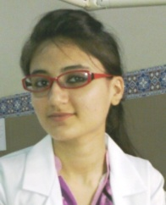

**Dr. Bushra Nazeer**

**BDS (Dentist)**

Dr. Ishrat-ul-Ebad Khan Institute of Oral Health Sciences, DUHS

Youth is the backbone for the nation's progress and development. I am strongly in favor with the theme of this year for IYD. Youth have the power, the motivation, the resolve and stand and deliver. What they lack is a vision, a picture and path to follow. So, if stakeholders are going to engage us in decision making processes, world will definitely become a better place.