CORRIGENDUM

Subject: Providing & Fixing of Roller Blinds PSF/BLINDS/06042020.

- Reference our original advertisement on PPRA websites dated 04.06.2020 for the subject tender, please note that, interested Firms may visit to the PSF office for examination sample of the said item (roller blinds). Sample attached herewith.
All other Terms & Conditions remains the same.
This advertisement is also available on PSF and PPRA websites accordingly.

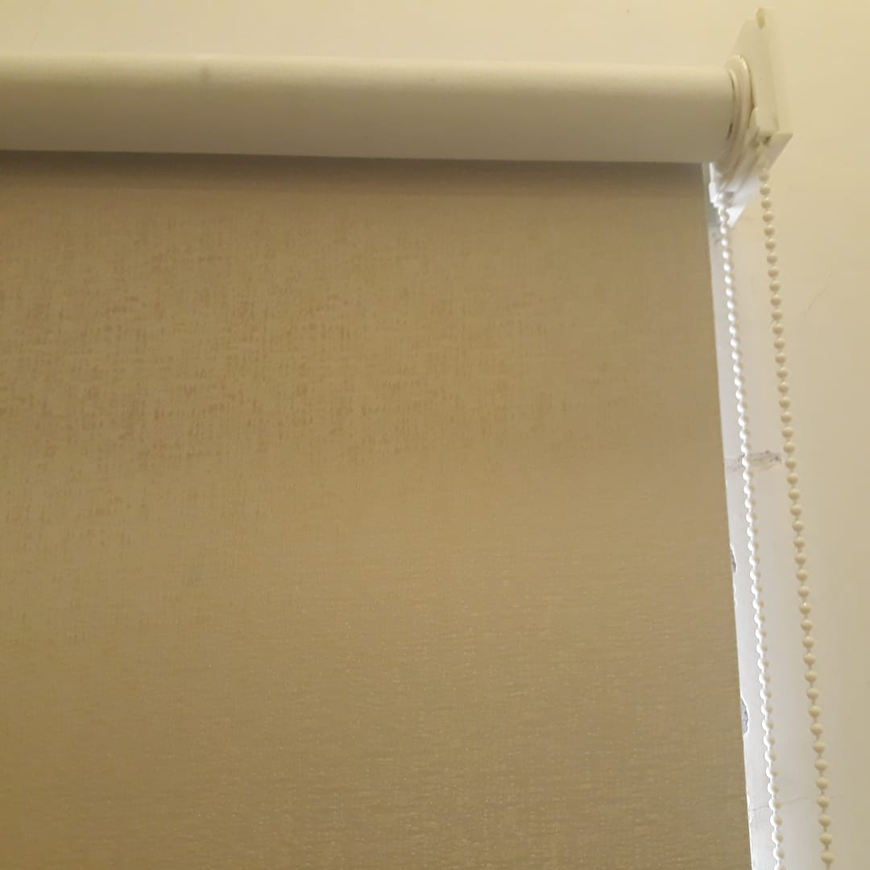

Pakistan Science Foundation
1-Constititution Avenue,G-5/2, Islamabad, Ph: 051-9206725 psf.gov.pk

